GEOL 4237
Chapter 8
Tsunami

- Japanese word: tsu=harbor, nami=waves

- Tsunami are the largest of all waves

- Travel at about 500 miles/hour
- "Tidal Wave" is in appropriate, not related to tides
- 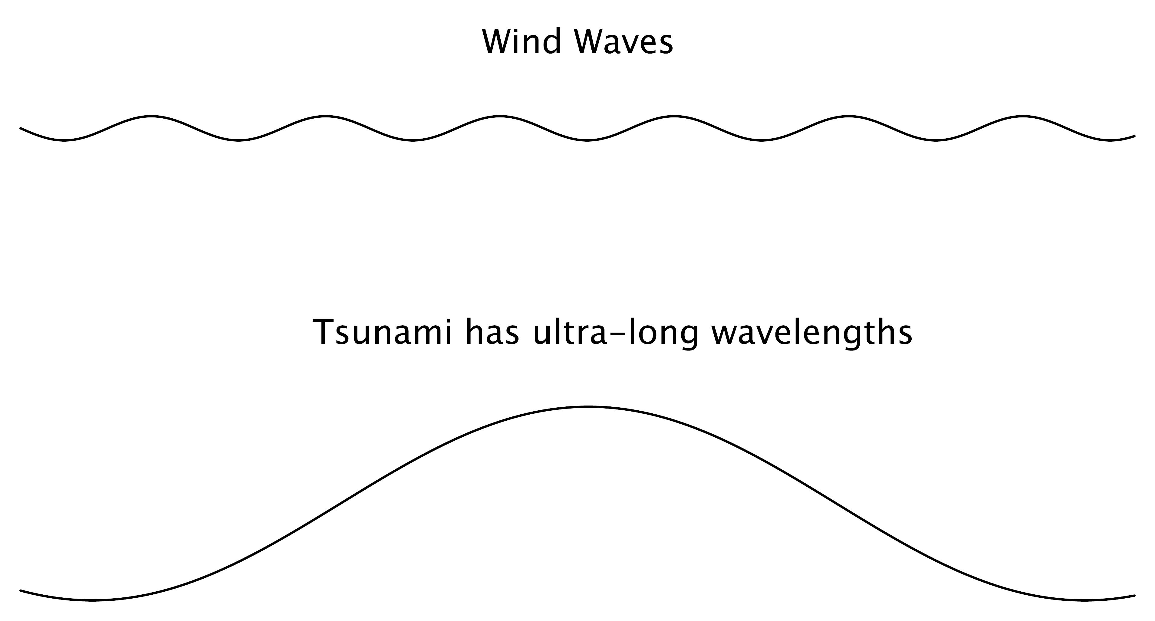
- Wind waves have short wavelengths
- Tsunami has ultra-long wavelengths
- These long wavelengths (i.e. long period) make them dangerous

- Tsunami grow larger in a harbor or other narrow space
- But often a narrow harbor will protect
- Depends on the inlet opening orientation and size

- 8 m wave on open ocean → 30 m wave in narrow harbor

Chapter 8
Tsunami
- Tsunami move faster in deep water
- Usually caused by Earthquakes
- Vertical shift of ocean floor

- Mostly at subduction zones in Pacific Ocean

- 70,000 people killed by tsunami in 20th century
- About 245,000 killed in Dec. 26, 2004 Indian Ocean
- About 19,184 killed in March 11, 2011 Japan
- World's most expensive disaster

- Wind waves
- Velocities Proportional to the period
- 17 mph for 5-second wave
- 70 mph for 20-second wave
- Tsunami
- Velocity: v = (g x D)^{1/2}
- g – acceleration due to gravity
- D – depth of ocean water
- For average D = 5,500 m, v = 232 m/sec (518 mi/hr)
- Will slow down as nearing shoreline but still freeway speeds

- Height: ~1 m in open ocean, 6 to 15 m in shallow water, higher in narrow topography

- Tsunami at the shoreline

- Not a gigantic version of breaking wave(but can sometimes be a breaking wave e.g. 2004 Indian Ocean)

- Very rapidly rising tide, rushing inland

- Tsunami waves are usually separated by 10-60 minutes

Occur most often in the Pacific and Indian Oceans.

Ordinary Waves

Pulses of energy moving through water mass causing particles of water to rotate in place (similar to seismic waves). At water depth of 1/2 wavelength: orbital motion ceases
Waves on the Coastline
Why a Wave Breaks

Waves slow down when depth is more shallow than wavelength
Friction on sea floor interferes with orbital motion of water particles & waves slow down
As waves slow, wavelengths decrease → water, waves grow higher
Finally wave breaks

Wind waves begin as tiny ripple – capillary waves

Height of wave depends on:
- Velocity of wind
- Duration of time wind blows
- Length of water surface (fetch) wind blows across
- wind direction consistency
Can travel thousands of kilometers away from winds that created them
GEOL 4237
Chapter 8
Tsunami

Rogue Waves
Wave sets collide with waves from other storms constructive and destructive interference creates sea swell
Can be short-lived, very tall rogue wave
May damage ships at sea or crash onto beach
Measured up to 34 m high (100 ft, 7 story building)

Summer versus Winter Beaches

Summer waves in North Hemisphere
smaller and more numerous
Waves push offshore sand up to build sandy beach

Winter storms are energetic
larger, longer wavelength waves
Waves erode beach sand and carry it offshore
GEOL 4237
Chapter 8
Tsunami
- Warnings
- Feel the earthquake
- See sea level draw down significantly
- Hear wave coming
- What to do
- Run to high ground immediately
- Run upstairs in well-built building
- Warning system
- First sensors activated in 2003
- Tsunami warning center in Honolulu for Pacific Ocean
- sea surface buoys and ocean bottom pressure sensors
- Satellites are too infrequent to be helpful.
1957 8.6 magnitude Earthquake in Aleutian Islands resulted in a Tsunami at Laie Point Oahu Hawaii.

- Japan, 1896
- Offshore earthquake shifted seafloor, causing tsunami to hit coastline 20 minutes later
- Highest waves (29 m) in narrow inlets
- 27,000 killed

- Japan, March 11, 2011
- 9.0 Magnitude Earthquake
- 20 foot Tsunami height warning 9 minutes later
- Tsunami hit 17 minutes after warning
- 101 Tsunami safe sites were overrun killing 19,000

Most expensive disaster in recorded history
Earthquake in Japan, March 11, 2011 20 ft Tsunami
- Vancouver Island 3 ft Tsunami
- Curry County Oregon 8 ft Tsunami, $7 million in damages
- Crescent City & Santa Cruz CA 8 ft Tsunami, $4 million in damges
- Antarctica - broke off 48 sq mi ice shelf

1700 Earthquake in the Northwest

- No major Earthquake in the last 200 years

- Victoria, Vancouver, Seattle, Tacoma and Portland - Huge Earthquake risk
- Are located on inlets so less affected by Tsunami
- Inlets seem somehow to protect an area from Tsunami
- Small coastal towns will be hammered by Tsunami

Indian Ocean Tsunami, Dec. 26, 2004

Sumatra
Seafloor dropped (20 m) over 1,200 km
2nd largest earthquake in last 100 years (magnitude 9.2)

Death toll > 245,000 in Indonesia, Thailand, India, and Sri Lanka.

The Tsunami moved from Sumatra to Sri Lanka in 2 hours (370 miles/hour)

Long wavelengths and long periods caused all sides of Sri Lanka to be hit hard
- 14,000 killed on the east shore
- 10,000 killed on the south shore

Another Tsunami hit Indonesia in March 28, 2005
GEOL 4237
Chapter 8
Tsunami

- Alaska, 1 April 1946
- Two large subduction zone earthquakes in Aleutian Islands created 30 m high tsunami
- Destroyed local lighthouse
- Raced across Pacific Ocean to Hilo, Hawaii – killed 159 people

Chile, 22 May 1960
- Magnitude 9.5 subduction event was most powerful earthquake ever recorded, created large tsunami
- Three waves, each successively larger, hit Chilean coast, killing 1,000 Chileans
- Adequate warning was given in Hawaii but 61 people killed
Tsunami continued to Japan, killing 185 people

- Chile, Feb. 27, 2010
- Magnitude 8.8
- 6th largest ever
- 24 foot Tsunami hit Chilean coast
- Killed 200

- Rupture too close
- No warning time
GEOL 4237
Chapter 8
Tsunami
Tsunami damage at Hilo Hawaii May 22, 1960 due to Chilean Earthquake

- Alaska, 27 March 1964
- Magnitude 9.2 subduction earthquake killed 122 people in sparsely populated Alaskan coast
- Tsunami hit Vancouver Island, then California
- Series of waves, with fifth one largest
- Which wave in series will be largest is not predictable

GEOL 4237
Chapter 8
Tsunami

- Nicaragua, 1 September 1992
- Very slow but large (magnitude 7.6) earthquake shook ground very little so was barely noticed
- 100 km segment of plate moved 1 m over two minutes
- Generated 10 m high tsunami to hit 300 km of coastline without warning

Papua New Guinea, 17 July 1998
- Magnitude 7.1 earthquake 20 km offshore, triggered underwater landslide that caused tsunami
- Hit coastline of Papua New Guinea about 5 minutes later, washing four villages on barrier beaches into lagoons
- Caused re-thinking of tsunami threat, as caused not just by large earthquakes but also by landslides triggered by moderate earthquakes
- 1929 Newfoundland Canada Earthquake caused a submarine landslide
- Slumping of flanks of Canary Island volcanoes
- Teide, Tenerife, Canary Islands the highest mountain (12,198 ft) in Spain has been the source of many huge Landslides and Tsunami.
- La Orotava valley was created in gigantic landslides 500,000 and 170,000 years ago, much like Mount St. Helens with huge eruptions following.

- Atlantic coastline:
- Risk due to volcanic flank collapse in Canary Islands
- Off east coast of North America, images show scars of big submarine landslides

1929 magnitude 7.2 Grand Banks earthquake triggered landslide that caused three tsunami waves to hit Newfoundland

- Southern California:
- Protected from distant tsunami by offshore islands
- Offshore islands were formed by active faults, that could cause landslides to generate local tsunami

Tsunami
Case Histories
1700 British Columbia, Washington & Oregon
- Magnitude 9 Earthquake created huge Tsunami
1918 Puerto Rico - submarine landslide in Puerto Rico Trench
- Slumping of flanks of Hawaii volcanoes
- Slumping of flanks of Hawaii volcanoes on the Big Island
- Hilina Slump in 1868 (77 deaths)
- 1975 Slump

Caribbean Tsunami
- Last 500 years - more than 75 tsunami in the Caribbean
- Since 1842 3,446 people killed
- Tsunami up to 10 m high
- Reach shore in minutes

- 2010 Haiti Earthquake created a tsunami that killed several people

- 1946 tsunami in Dominican Republic
- 1,800 victims

- Unesco advocated a warning system for the Caribbean in 1995
- CARIBE EWS (Early Earning System) established 2006
- Caribbean Early Warning System
- DART buoys
- COCO GPS & seismic stations
- Gloss sea level stations
- Science Aug. 30 2013
- Seiche (tsunami in enclosed area)
- Largest ever known was caused by rockfall in Lituya Bay in Alaska, 1958 – up to 520 m high

- Seiche waves oscillate back and forth in a lake or bay
- Lake shores are at risk from seiche waves also
- Active faults run under Lake Tahoe

- Glacier Bay National Park Alaska, Juy 9, 1958
- 900 m rockslide of 90 million tons 1958
- Tsunami of 525 meters (1,700 feet)

